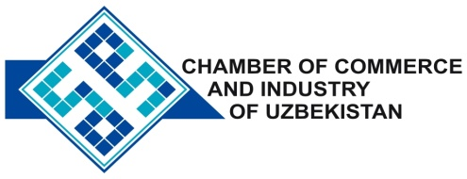

**Commercial offer of Uzbek Products to Foreign Buyer**

Dear Sirs, №PSM-012

We offer quotation of Uzbek Company LLC «ZEIGER IMPEX».

**Information about the company:**

«ZEIGER IMPEX» Ltd. is engaged production of building products mixtures by European technologies. The range of products «ZEIGER IMPEX» covers the entire spectrum of facing works. The company's products provide water resistant and have a long service life. Used in the lining of the facade, the interior decoration, rooms with high humidity and other non-standard climatic conditions. The antibacterial properties of the product prevent the formation of fungi, moss and bacteria indoors.

**List of products:**

Putty gypsum

Putty facade

Clay tile

"Economy" Clay

**Benefits:**

High quality, reasonable price, meets all international requirements.

**Terms of delivery:** FCA Tashkent

If you are interested, we are happy to provide additional information in accordance with your request.

E-mail: export@chamber.uz

Website: www.chamber.uz

Export Promotion Department .

Chamber of Commerce of the Republic of Uzbekistan .